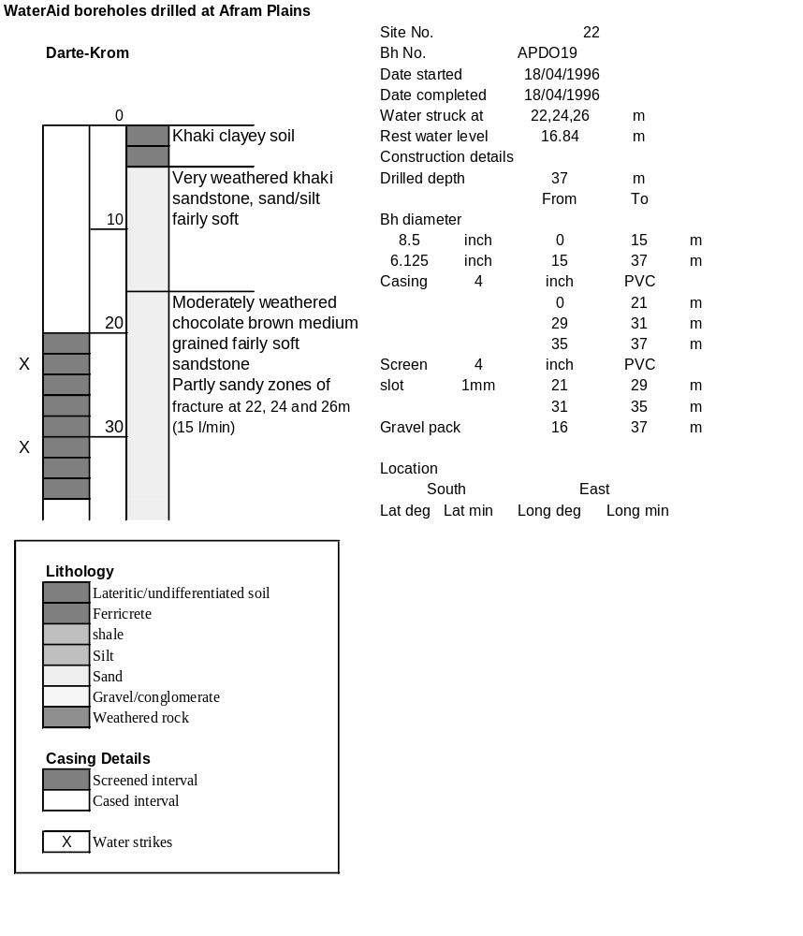

Ghana | Test pumping
Borehole No. |  | APDO19
Hole No |  | 22
Village |  | Darte-krom
Date |  | 22/04/1996
Point above GL |  | 0.5 | m
Pump depth |  | 36 | m
SWL |  | 17.34 | m
Start Time |  | 08:30
Drawdown test |  |  |  |  | Recovery test
time | pwl (m) | Q l/min | s (m) | sc | Time | wl (m) | s' (m) | t/t'
0.00 | 17.34 | 15.00 | 0.00 |  | 0.00 | 30.90 | 13.56
1.00 | 20.68 | 15.00 | 3.34 | 4.49 | 1.00 | 29.59 | 12.25 | 181.00
2.00 | 21.10 | 15.00 | 3.76 | 3.99 | 2.00 | 28.45 | 11.11 | 91.00
3.00 | 21.36 | 15.00 | 4.02 | 3.73 | 3.00 | 27.30 | 9.96 | 61.00
4.00 | 21.68 | 15.00 | 4.34 | 3.46 | 4.00 | 26.22 | 8.88 | 46.00
5.00 | 21.93 | 15.00 | 4.59 | 3.27 | 5.00 | 25.17 | 7.83 | 37.00
6.00 | 22.44 | 15.00 | 5.10 | 2.94 | 6.00 | 24.20 | 6.86 | 31.00
7.00 | 22.84 | 15.00 | 5.50 | 2.73 | 7.00 | 23.53 | 6.19 | 26.71
8.00 | 23.24 | 15.00 | 5.90 | 2.54 | 8.00 | 22.92 | 5.58 | 23.50
9.00 | 23.65 | 15.00 | 6.31 | 2.38 | 9.00 | 22.39 | 5.05 | 21.00
10.00 | 23.90 | 15.00 | 6.56 | 2.29 | 10.00 | 21.93 | 4.59 | 19.00
11.00 | 24.16 | 15.00 | 6.82 | 2.20 | 12.00 | 21.18 | 3.84 | 16.00
12.00 | 24.48 | 15.00 | 7.14 | 2.10 | 14.00 | 20.75 | 3.41 | 13.86
13.00 | 24.81 | 15.00 | 7.47 | 2.01 | 16.00 | 20.48 | 3.14 | 12.25
14.00 | 25.16 | 15.00 | 7.82 | 1.92 | 18.00 | 20.30 | 2.96 | 11.00
15.00 | 25.48 | 15.00 | 8.14 | 1.84 | 20.00 | 20.12 | 2.78 | 10.00
16.00 | 25.80 | 15.00 | 8.46 | 1.77 | 22.00 | 19.87 | 2.53 | 9.18
17.00 | 26.16 | 15.00 | 8.82 | 1.70 | 24.00 | 19.65 | 2.31 | 8.50
18.00 | 26.36 | 15.00 | 9.02 | 1.66 | 26.00 | 19.46 | 2.12 | 7.92
19.00 | 26.64 | 15.00 | 9.30 | 1.61 | 28.00 | 19.30 | 1.96 | 7.43
20.00 | 26.90 | 15.00 | 9.56 | 1.57 | 30.00 | 19.17 | 1.83 | 7.00
22.00 | 27.39 | 15.00 | 10.05 | 1.49 | 35.00 | 18.93 | 1.59 | 6.14
24.00 | 27.80 | 15.00 | 10.46 | 1.43 | 40.00 | 18.73 | 1.39 | 5.50
26.00 | 28.14 | 15.00 | 10.80 | 1.39 | 45.00 | 18.56 | 1.22 | 5.00
28.00 | 28.48 | 15.00 | 11.14 | 1.35 | 50.00 | 18.40 | 1.06 | 4.60
30.00 | 28.78 | 15.00 | 11.44 | 1.31 | 60.00 | 18.19 | 0.85 | 4.00
35.00 | 29.46 | 15.00 | 12.12 | 1.24 | 70.00 | 17.99 | 0.65 | 3.57
40.00 | 29.00 | 13.00 | 11.66 | 1.11 | 80.00 | 17.88 | 0.54 | 3.25
45.00 | 28.67 | 13.00 | 11.33 | 1.15 | 90.00 | 17.79 | 0.45 | 3.00
50.00 | 28.48 | 13.00 | 11.14 | 1.17 | 100.00 | 17.73 | 0.39 | 2.80
55.00 | 28.44 | 13.00 | 11.10 | 1.17 | 110.00 | 17.69 | 0.35 | 2.64
60.00 | 28.45 | 13.00 | 11.11 | 1.17 | 120.00 | 17.65 | 0.31 | 2.50
70.00 | 28.50 | 13.00 | 11.16 | 1.16
80.00 | 28.70 | 13.00 | 11.36 | 1.14
90.00 | 28.87 | 13.00 | 11.53 | 1.13
100.00 | 29.11 | 13.00 | 11.77 | 1.10
110.00 | 29.35 | 13.00 | 12.01 | 1.08
120.00 | 29.60 | 13.00 | 12.26 | 1.06
130.00 | 29.87 | 13.00 | 12.53 | 1.04
140.00 | 30.16 | 13.00 | 12.82 | 1.01
160.00 | 30.53 | 13.00 | 13.19 | 0.99
180.00 | 30.90 | 13.00 | 13.56 | 0.96
